**CP Club 365 Days Challenge**

**Programming language – C++**

**Problem Statement**

<https://www.codechef.com/problems/KITCHENTIME>

**Your Code**:

// 0x74Day of 0x365Days challenge

// VEDANT BHARAD

// 30-12-2022

#include <iostream>

using namespace std;

int main() {

    // your code goes here

    int t;

    cin >> t;

    while (t--) {

        int x,y;

        cin>>x>>y;

        cout<<(y-x)<<endl;

    }

    return 0;

}

**Output (Screen Shot)**:

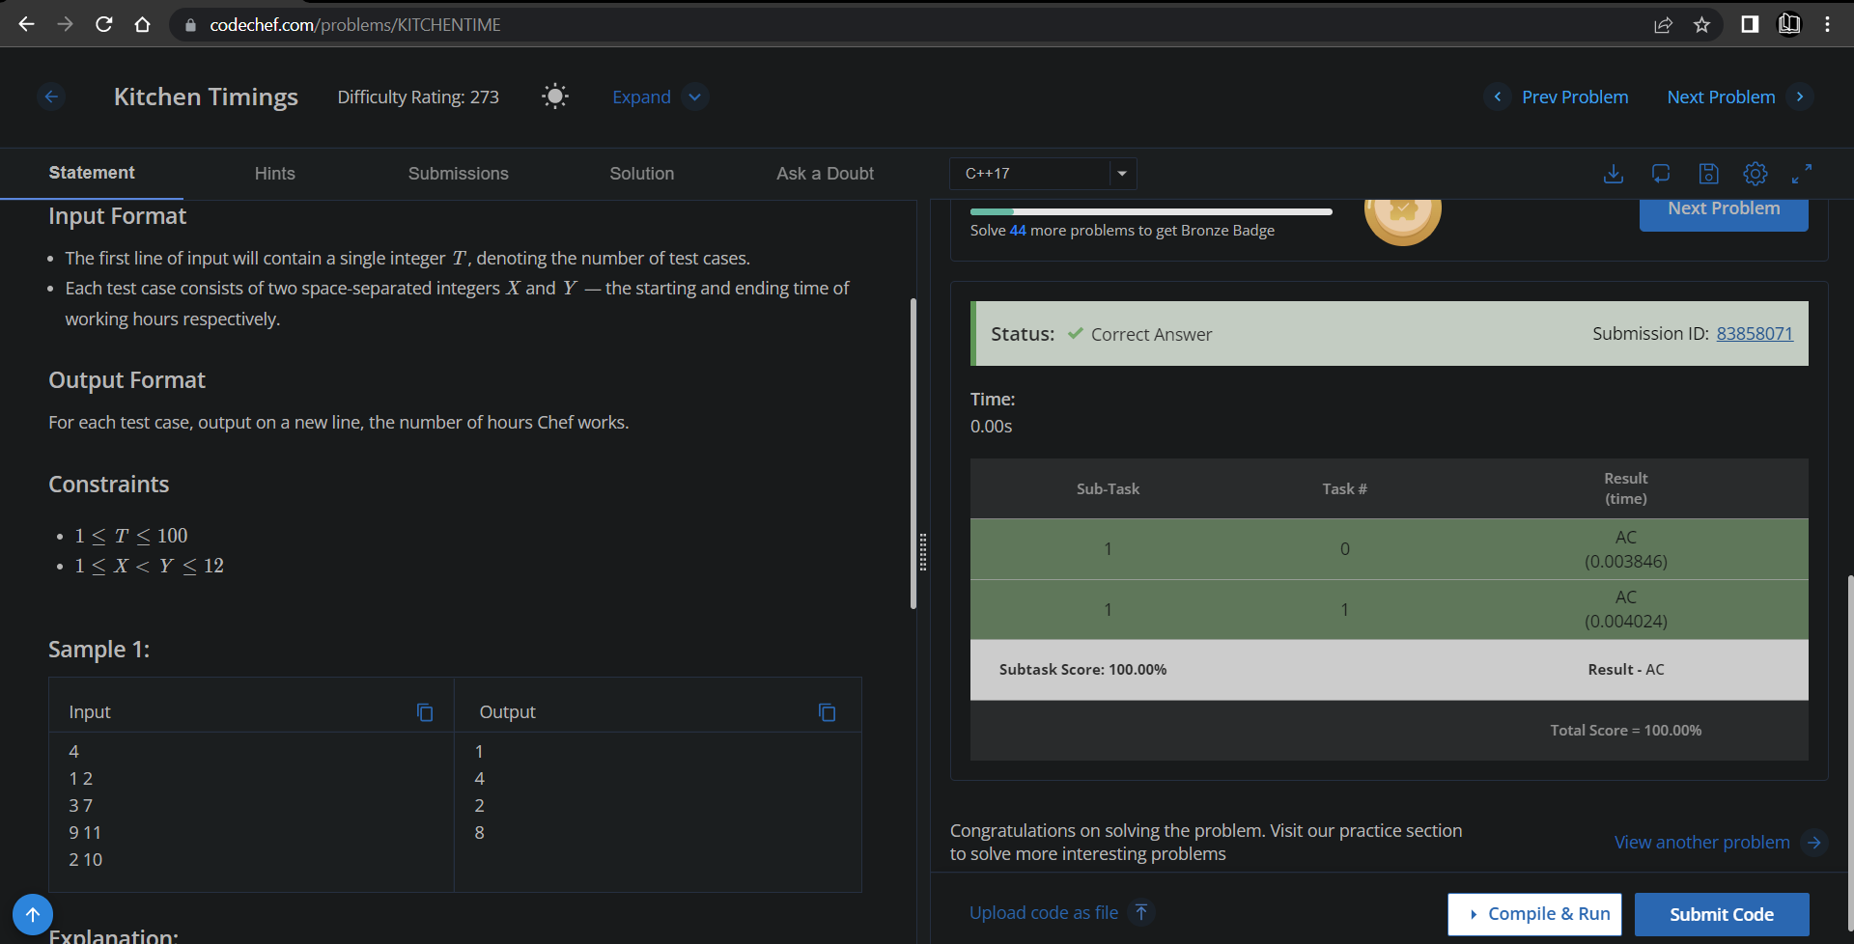

**Understanding about problem:**

* In this task I need to find working hours of Chef form starting time(x) and ending time(y) and return (y-x).

Note: If you can't understand the problem, feel free to contact us and we'll help you. Please don't copy and paste from anywhere.

ALL THE BEST

Team CP Club